Banner Component

Properties Tab

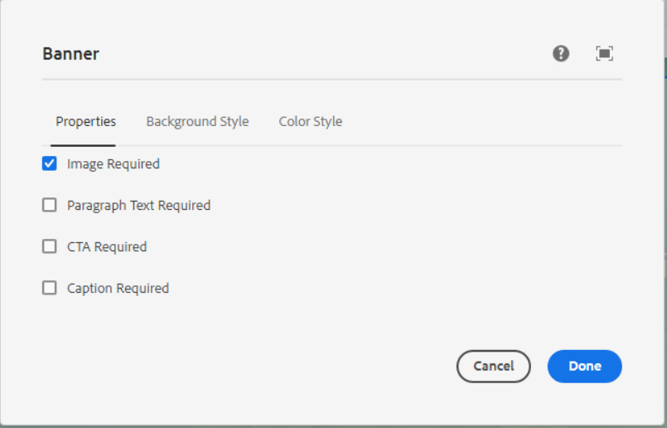

**Image Required** – If we want to author icon image before the heading text then select this option

**Paragraph Text Required** – If we want paragraph text then select this option

**CTA Required** - If we want CTA then select this option

**Caption Required** - If we want Caption text then select this option

___________________________________________________________________

Background Style Tab

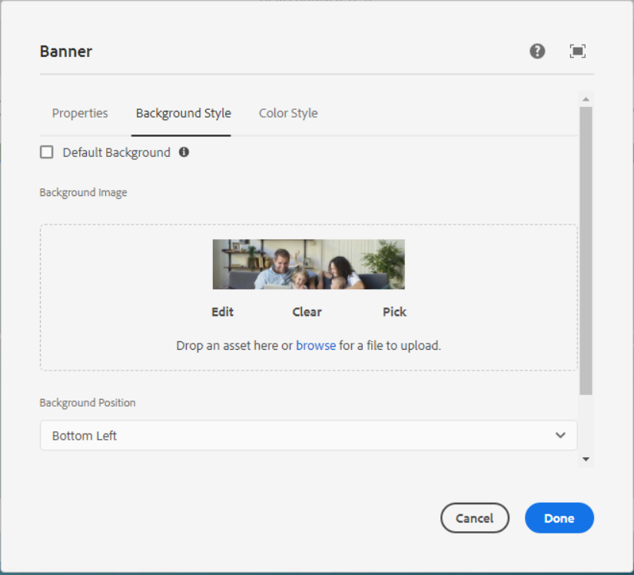

**Default Background Checkbox** - This property takes priority over other background image and background color properties. This is used for blog page's hero banner

**Background Image** – Here we can edit, clear or pick any image as per the requirement.

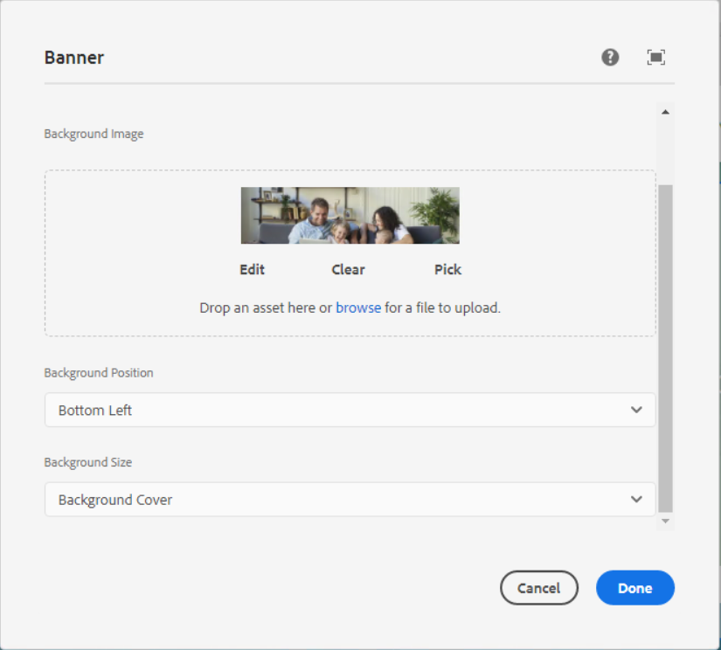

**Background Position** – In this dropdown below list of positions are available, we can select one position as per our requirement.

1. Bottom Left

- background-position: 0px 0px, 50% 50%;

2. Bottom Center

- background-position: 0px 0px, 50% 0%;

3. Bottom Left center

- background-position: 0px 0px, 100% 50%;

4. Bottom

- background-position: 0px 0px, 100% 0%;

5. Bottom left right

- background-position: 0px 0px, 50% 20%;

6. Right bottom

- background-position: 0px 0px, 100% 50%, 0px 0px;

7. center top

- background-position: 50% 25%;

8. Center small

- background-position: 50% 0%;

9. Left Center

- background-position: 8% 50%;

10. Right crop

- background-position: 50% -85px;

**Background Cover** – In this dropdown below list of position are available, we can select one position as per our requirement.

1. Background Cover

background-size: auto, cover;

1. Background Half Cover

background-size: auto, 50%, auto;

1. Background Full Cover

background-size: cover;

___________________________________________________________________

Color Style Tab

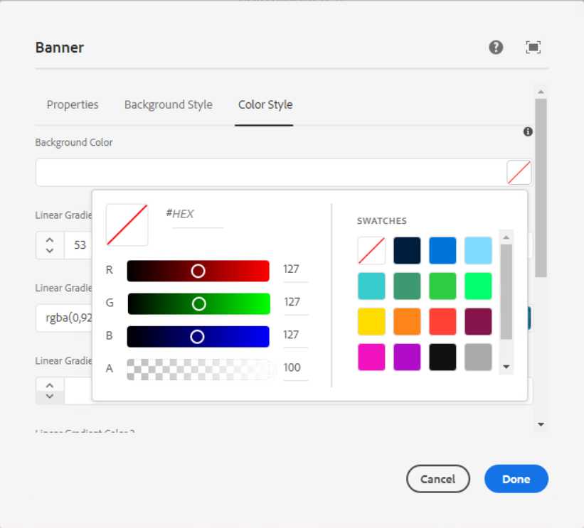

**Background Color** – Pick any color as per our requirement in hex or RGBA format.

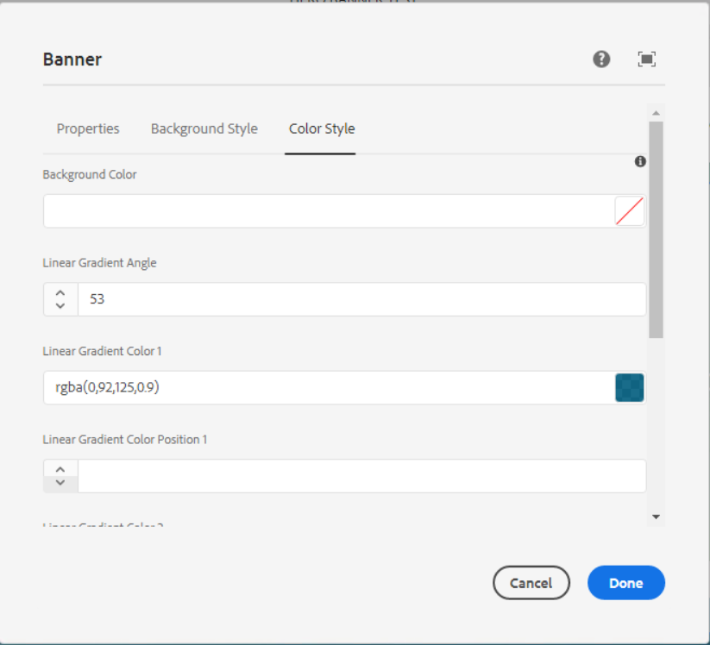

**Linear Gradient Angle** – Here we can set the angle of the background Image

**Liner Gradient Color and Liner Gradient Color Position** – Here we have 3 options to add color and position.

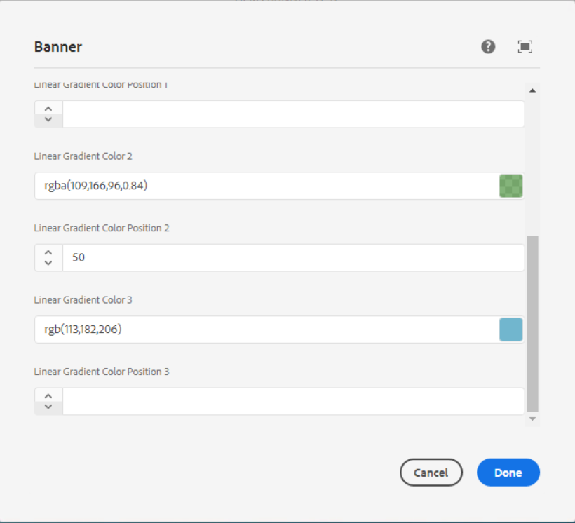

___________________________________________________________________

Style options

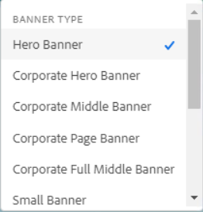

**Banner type** – Here we can select any one banner type as per our requirement.

1. **Hero Banner**

Page Reference - <https://www.ancestry.com/corporate/>

AEM URL - [https://author-ancestry-dev2.adobecqms.net/content/ancestry-corp/us/en](https://author-ancestry-dev2.adobecqms.net/content/ancestry-corp/us/en/about-ancestry/our-team.html?wcmmode=disabled)[.html?wcmmode=disabled](http://localhost:4502/content/ancestry-corp/us/en.html?wcmmode=disabled)



1. **Corporate Hero Banner**

Page Reference - <https://www.ancestry.com/corporate/corporate-responsibility>

AEM URL - [https://author-ancestry-dev2.adobecqms.net/content/ancestry-corp/us/en](https://author-ancestry-dev2.adobecqms.net/content/ancestry-corp/us/en/about-ancestry/our-team.html?wcmmode=disabled)[/corporate-responsibility.html?wcmmode=disabled](http://localhost:4502/content/ancestry-corp/us/en/corporate-responsibility.html?wcmmode=disabled)



1. **Corporate Middle Banner**

Page Reference - <https://www.ancestry.com/corporate/corporate-responsibility>

AEM URL - [https://author-ancestry-dev2.adobecqms.net/content/ancestry-corp/us/en](https://author-ancestry-dev2.adobecqms.net/content/ancestry-corp/us/en/about-ancestry/our-team.html?wcmmode=disabled)[/corporate-responsibility.html?wcmmode=disabled](http://localhost:4502/content/ancestry-corp/us/en/corporate-responsibility.html?wcmmode=disabled)



1. **Corporate Page Banner**

Page Reference - <https://www.ancestry.com/corporate/corporate-responsibility>

AEM URL - [https://author-ancestry-dev2.adobecqms.net/content/ancestry-corp/us/en](https://author-ancestry-dev2.adobecqms.net/content/ancestry-corp/us/en/about-ancestry/our-team.html?wcmmode=disabled)[/corporate-responsibility.html?wcmmode=disabled](http://localhost:4502/content/ancestry-corp/us/en/corporate-responsibility.html?wcmmode=disabled)



1. **Corporate Full Middle Banner**

Page Reference - <https://www.ancestry.com/corporate/corporate-responsibility>

AEM URL - [https://author-ancestry-dev2.adobecqms.net/content/ancestry-corp/us/en](https://author-ancestry-dev2.adobecqms.net/content/ancestry-corp/us/en/about-ancestry/our-team.html?wcmmode=disabled)[/corporate-responsibility.html?wcmmode=disabled](http://localhost:4502/content/ancestry-corp/us/en/corporate-responsibility.html?wcmmode=disabled)



1. **Small Banner**

Page Reference - <https://www.ancestry.com/corporate/ca/contact>

AEM URL - [https://author-ancestry-dev2.adobecqms.net/content/ancestry-corp/us/en](https://author-ancestry-dev2.adobecqms.net/content/ancestry-corp/us/en/about-ancestry/our-team.html?wcmmode=disabled)[/corporate-responsibility.html?wcmmode=disabled](http://localhost:4502/content/ancestry-corp/us/en/corporate-responsibility.html?wcmmode=disabled)



1. **Banner Card**

Page Reference - <https://www.ancestry.com/corporate/about-ancestry/our-brands>

AEM URL - [https://author-ancestry-dev2.adobecqms.net/content/ancestry-corp/us/en](https://author-ancestry-dev2.adobecqms.net/content/ancestry-corp/us/en/about-ancestry/our-team.html?wcmmode=disabled)[/](http://localhost:4502/content/ancestry-corp/us/en/corporate-responsibility.html?wcmmode=disabled)[about-ancestry/our-brands.html?wcmmode=disabled](http://localhost:4502/content/ancestry-corp/us/en/about-ancestry/our-brands.html?wcmmode=disabled)

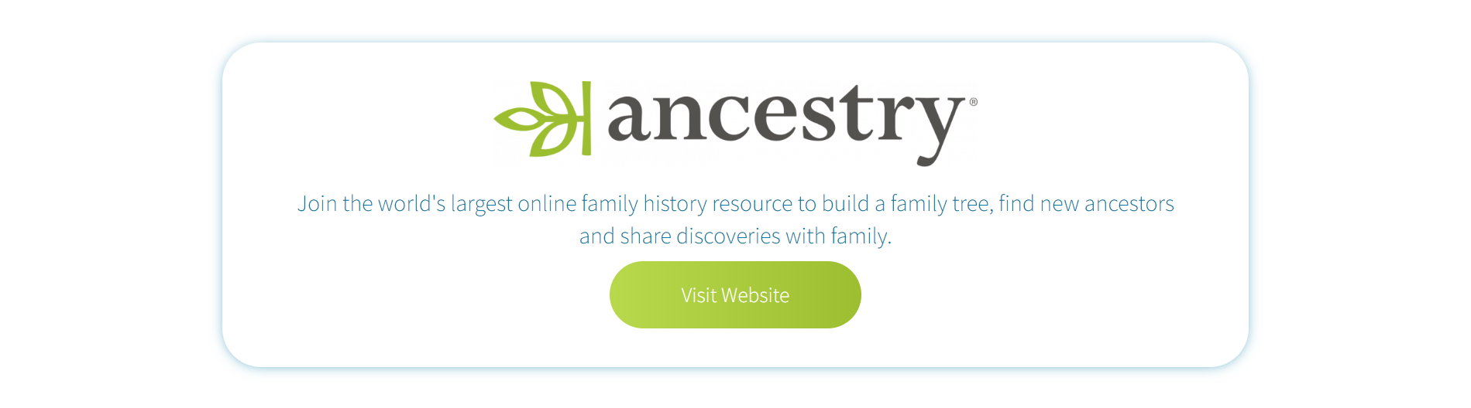

------------------------------------------------------------------------------------------------------------

**Font Style** – This is for banner heading text, select one style as per the requirement

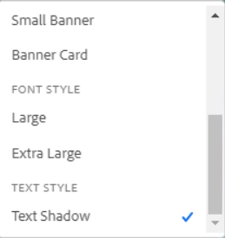

1. **Large**

Page Reference - <https://www.ancestry.com/corporate/blog/give-more-meaning-spring-cleaning-new-tools-preserve-family-photos-forever>

AEM URL - [https://author-ancestry-dev2.adobecqms.net/content/ancestry-corp/us/en](https://author-ancestry-dev2.adobecqms.net/content/ancestry-corp/us/en/about-ancestry/our-team.html?wcmmode=disabled)[/](http://localhost:4502/content/ancestry-corp/us/en/corporate-responsibility.html?wcmmode=disabled)[blog/give-more-meaning-spring-cleaning-new-tools-preserve-family-photos-forever.html?wcmmode=disabled](http://localhost:4502/content/ancestry-corp/us/en/blog/give-more-meaning-spring-cleaning-new-tools-preserve-family-photos-forever.html?wcmmode=disabled)



1. **Extra Large**

Page Reference - <https://www.ancestry.com/corporate/about-ancestry/our-team>

AEM URL - <https://author-ancestry-dev2.adobecqms.net/content/ancestry-corp/us/en/about-ancestry/our-team.html?wcmmode=disabled>



------------------------------------------------------------------------------------------------------------

**Text style** – For heading text shadow



Page Reference - <https://www.ancestry.com/corporate/>

AEM URL - <https://author-ancestry-dev2.adobecqms.net/content/ancestry-corp/us/en.html?wcmmode=disabled>

